Spirent-pep-logo

**Design Document:**

**TCP Socket Chat System**

Revision 1.0

17/04/2018

**KyungHee University**

**Hyunkyun Moon**

Table of Contents

1. Introduction 3

1.1. Purpose 3

1.2. Audience 3

1.3. Environment 3

1.4. Tasks 3

2. Software Design 4

2.1. Overview 4

2.2. Class Diagram 5

3. Chat System Compiling 9

# Introduction

This project is Chat System by TCP.

This project will be implemented with the following configurations:

* Server
  + Server will written by C++
  + TCP socket
  + Multithread – server spawns one thread per client.
  + Store user profile (name, user id, password, status (online, offline, and busy)) and chat history.
  + Message delivery
    - Online/busy delivery – server should forward messages between online clients.
    - Offline delivery – server should store the message and forward the message when user is online.
    - Record time stamp for every message.
* Client
  + Client will written by Objective-C
  + Create user profile (login and password creation and authentication).
  + Register to server and connect.
  + Retrieve chat history.
  + Check peer status (online, offline, busy).
  + Send and receive message.

## Purpose

The purpose of this document is to describe the design of Chat System for internship.

## Audience

This document is intended for Spirent.

## Environment

* IDE: Xcode
* Compiler: g++ & LLVM Compiler
* Language: C++ & Objective-C

## Tasks

|  |  |
| --- | --- |
| ###ERQ1 | Make TCP Socket |
| ###ERQ2 | Connect Database |
| ###ERQ3 | Encrypt password by scrypt |

# Software Design

## Overview

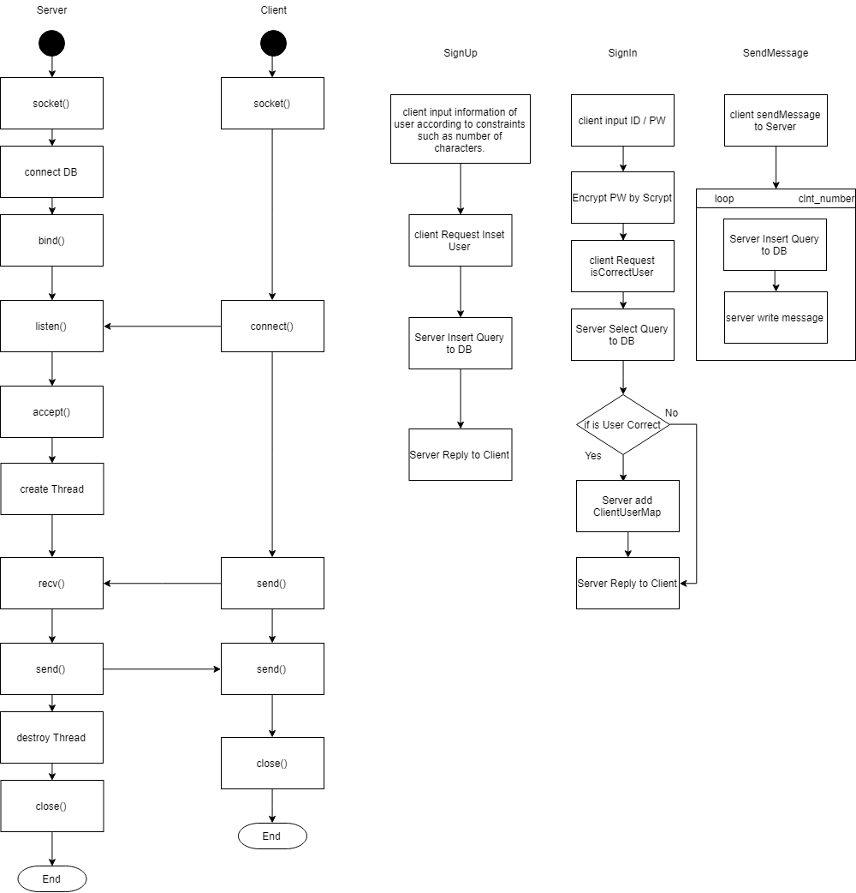

**Figure 1.** FlowChart

## Class Diagram

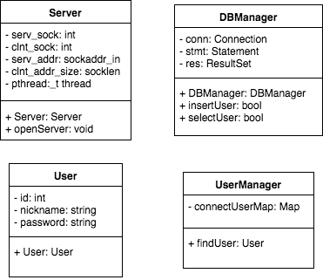

**Figure 2.** Class diagram.

# Chat System Compiling

Compile each time we make clean and build.

The following are instructions on how to compile server source:

1. go to Server/Server
2. at command line
3. g++ -I./boost_1_67_0 -L -lmysqlcppconn main.cpp main.cpp –o chat.out
4. ./chat.out 1111(port)